EXP NO :1
18 BIT-ADDITION

LDA 8050
MOV B,A
LDA 8051
ADD B
STA 8052
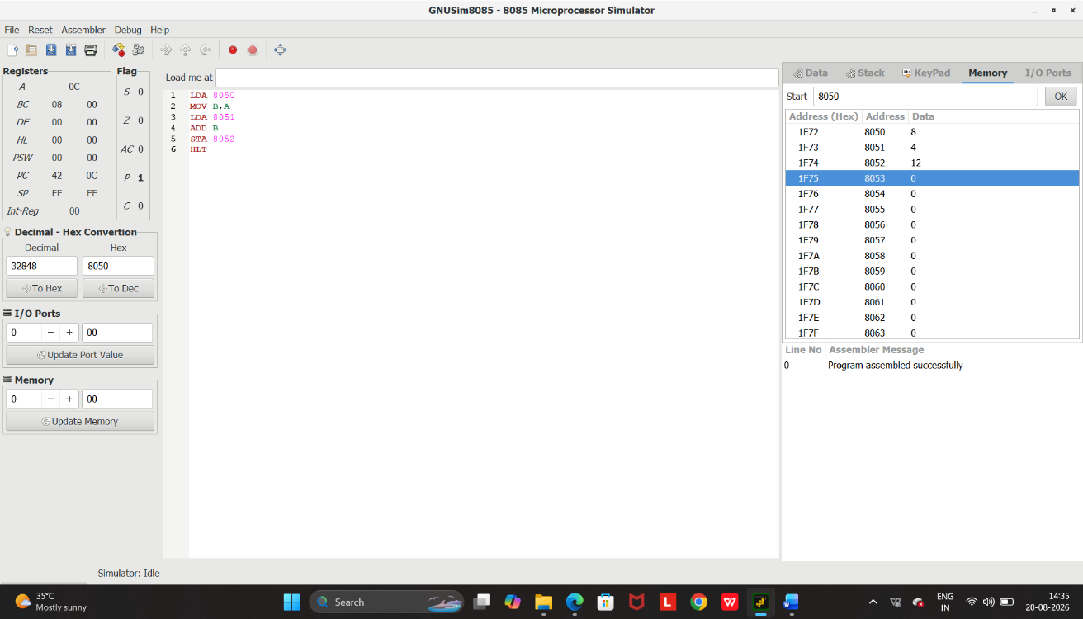
HLT

